Chapter 3
MATERIALS AND METHODOLOGY

This chapter introduces the proposed system which consists of architecture, objectives, need and advantages of the system.

3.1 Analysis and Feasibility of Study
A feasibility study sometimes called a feasibility analysis or feasibility report is a way to evaluate whether or not a project plan could be successful. A feasibility study evaluates the practicality of your project plan in order to judge whether or not you're able to move forward with the project.
System analysis is usually the first phase of a large-scale software development project and for this project we start from the basic need of the system mentioned above. The purpose of this phase is to identify and document the exact requirements for the system. There are two major activities in this phase: problem understanding or analysis and requirement specification. In problem analysis, the analyst has to understand the problem and its context. In requirement specification, the analyst has to understand what the exact requirements of the customer are. The goal of this activity is to understand the requirements of the new system that is to be developed.

3.1.1 Introduction
There are two tasks basically accomplished under this phase of software development process, they are:
- Analyzing or understanding the problem statement.
- Development of requirement specification.
In problem analysis, the problem analyst has to understand the problem and its context. He has to analyze the technical skills and capabilities of the software development team members and determine whether the relevant technology is stable and established. In requirement specification, the analyst has to understand what the exact requirements of the user are. The goal of this activity is to understand the requirements of the new system that is to be developed. Hence while doing the system analysis requirements of the user should be kept in mind and should be done in a careful manner.

3.1.2 Identification of Need
This most important thing about developing this system is to identify the exact requirement of the customer. In this system, firstly we have mentioned our need which we want to develop. The need and specification phase of system analysis is done in this system to find the exact requirement of the customer. In this phase we collect all the necessary information of the customer which he wants in their system.
Technical feasibility assesses the current resources (such as hardware and software) and technology, which are required to accomplish user requirements in the software within the allocated time and budget. For this, the software development team ascertains whether the current resources and technology can be upgraded or added in the software to accomplish specific user requirements. Technical feasibility also performs the following tasks.
- Analyzes the technical skills and capabilities of the software development team members.
- Determines whether the relevant technology is stable and established.
- Ascertains that the technology chosen for software development has a large number of users so that they can be consulted when problems arise or improvements are required. Economic feasibility determines whether the required software is capable of generating financial gains for an organization. It involves the cost incurred on the software development team, estimated cost of hardware and software, cost of performing feasibility study, and so on.

3.1.3 Preliminary Investigation
Preliminary investigation helps to outline the feasibility of the project, whether the proposed application would be helpful for the organization or not. The activities undergone during this phase are as mentioned below:
- Information assessment: Identifies information about whether the system helps in achieving the objectives of the organization. It also verifies that the system can be implemented using new technology and within the budget and whether the system can be integrated with the existing system.
- Information collection: Specifies the sources from where information about software can be obtained. Generally, these sources include users (who will operate the software), organization (where the software will be used), and the software development team (which understands user requirements and knows how report writing uses a feasibility report, which is the conclusion of the feasibility study by the software development team. It includes the recommendations whether the software development should continue. This report may also include information about changes in the software scope, budget, and schedule and suggestions of any requirements in the system.
- General information: Describes the purpose and scope of feasibility study. It also describes system overview, project references, acronyms and abbreviations, and points of contact to be used. System overview provides description about the name of the organization responsible for the software development, system name or title, system category, operational status, and so on.

3.1.4 Study of Feasibility
After the initial investigation process gets completed, the results are considered as the basis for the further detailed survey i.e., the feasibility study. The objective of the feasibility study is not to solve the problem but to acquire a range of its scope. Feasibility study can be understood as the assessment of the product about its impact, how successful will it be fulfilling the requirements of the user. In this project feasibility study is categorized into three subparts namely:
- Operational feasibility.
- Technical feasibility and
- Economic feasibility
- Operational Feasibility
- This application is operationally feasible because all the users can easily operate and access the facilities meant for them.
- The resource can be utilized in an efficient manner due to the well-planned architecture of the application.
- The well-planned architecture would also ensure the security against threats.
- Technical Feasibility
Technical feasibility evaluates the available infrastructure (such as hardware and software) and technologies needed to meet the consumer needs of software under time and budget constraints. The product development team determines whether current tools and technology should be modified or applied to the program to fulfil the identified users’ needs. The following are the activities often performed by technical feasibility.
- Examines the technological expertise and talents of members of the software development team.
- Determines whether the application infrastructure is reliable and well-established.
- Ensures that the technology selected for software creation has many customers who can be contacted when issues emerge or required changes.
- Economic Feasibility
The extent to which the required software completes a sequence of steps to address market challenges and consumer requirements is measured by operational viability. This Feasibility is based on human capital (the product development team) and entails visualizing whether the software can work after it is built and be operational after it is installed. The following are the operations carried out by operational feasibility:
- Determines whether the issues outlined in the consumer specifications are a high priority.
- Determines whether the software development team’s proposed approach is suitable.
- Determines whether or not consumers can respond to new technologies.
- Determines whether the possible solutions suggested by the software development team satisfy the company.

3.1.5 Project Planning
Project planning is part of project analysis, which relates to the use of schedules such as Gantt charts to plan and subsequently report progress within the project environment. Project planning can be done manually or by the use of project management software. Initially, the project scope is defined and the appropriate methods for completing the project are determined. Following this step, the durations for the various tasks necessary to complete the work are listed and grouped into a work breakdown structure. Project planning is often used to organize different areas of a project, including project plans, workloads and the management of teams and individuals. The logical dependencies between tasks are defined using an activity network diagram that enables identification of the critical path. Project planning is inherently uncertain as it must be done before the project is actually started. Therefore, the duration of the tasks is often estimated through a weighted average of optimistic, normal, and pessimistic cases. The critical chain method adds "buffers" in the planning to anticipate potential delays in project execution. Float or slack time in the schedule can be calculated using project management software. Then the necessary resources can be estimated and costs for each activity can be allocated to each resource, giving the total project cost. At this stage, the project schedule may be optimized to achieve the appropriate balance between resource usage and project duration to comply with the project objectives. Once established and agreed, the project schedule becomes what is known as the baseline schedule.
- The planning phase itself takes a couple of days. These are the requirements for project planning.
- It provides the important basis for project management and hence increase the management of the project.
- The project plan is usually produced before the development process begins and is updated as the development further proceeds and data about progress of the project becomes available.
- In this website, planning is done for developing the website which meets the user’s needs.

3.2 Design and Architecture
This topic describes the software functions and features. It includes functional diagrams, screen layouts, business rules, business process diagrams, and an entity-relationship diagram with a full data dictionary.
The block diagram below offers a simplified representation of the system architecture for “HandTalk: Real-Time Hand Sign Recognition”. It highlights the flow of data through various components such as input capture, preprocessing, model prediction, and output generation.
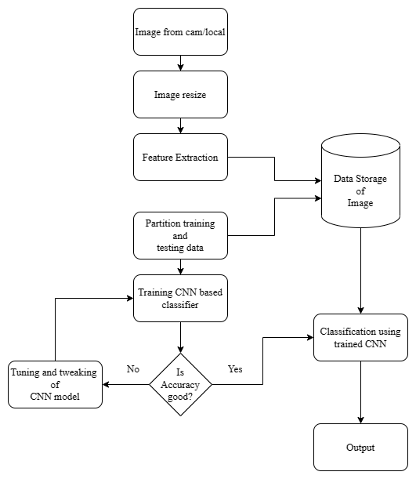
Figure 3.1: Block Diagram
The Figure 3.1 shows the block diagram of the Desktop application from the level of Data collection to building a model and utilizing that model from backend and to show the result in a frontend.

3.2.1 Introduction
The project, “HandTalk: Real-Time Hand Sign Recognition”, is a Deep Learning-based desktop application designed to detect and recognize American Sign Language (ASL) gestures in real time. This system primarily serves the hearing-impaired community, enabling communication with those who may not be familiar with sign language. The application utilizes Mediapipe for efficient hand-tracking and TensorFlow to implement deep learning models for gesture recognition. The custom GUI for the project is built using Tkinter, providing an intuitive interface for the users. Deep Learning, a subset of Machine Learning (ML), is at the core of this application. It leverages neural networks to automatically learn and extract patterns from large datasets. In this case, the application relies on a trained model to predict hand signs from video input. The entire process is two-fold: first, Mediapipe captures and processes the hand's movement and structure in real time, feeding the data to the deep learning model. Second, the trained TensorFlow model classifies these movements into recognized signs, displaying the output in a user-friendly GUI.
The following use case diagram illustrates the different ways a user interacts with the system. It highlights the core functionalities provided by the application, such as live hand sign detection, word formation, and text-to-speech conversion.
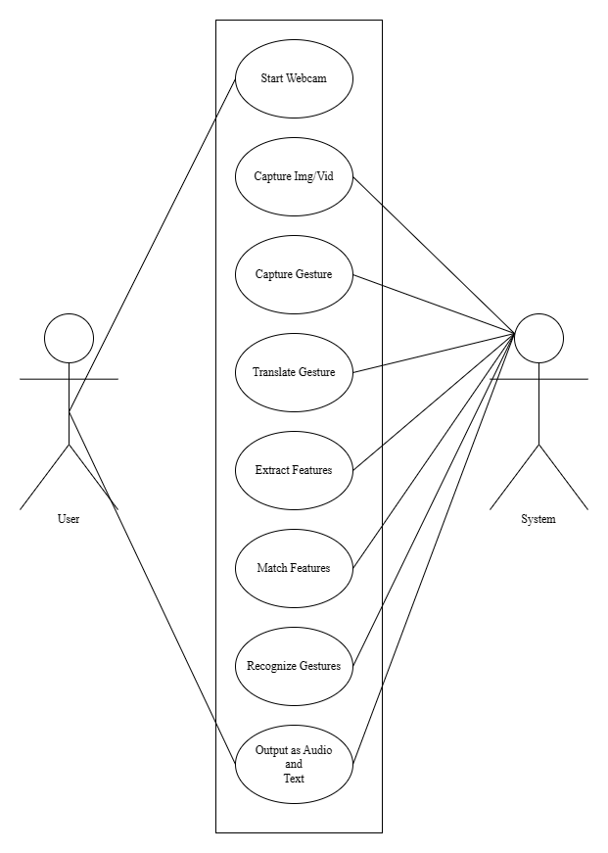
Figure 3.2: Use Case Diagram

3.2.2 Modularization Details
The “HandTalk: Real-Time Hand Sign Recognition system” is divided into several functional modules to ensure a smooth, user-friendly experience and efficient performance. The modular design allows for the application to be organized, manageable, and scalable. Each module has its own defined task and works in coordination with the others to deliver the overall functionality of the system. The following are the key functional modules:
- Live Camera Feed Module
  - This module captures real-time video feed from the user’s webcam. It is responsible for continuously providing the live hand gestures as input to the system. The camera feed serves as the foundation for recognizing hand gestures, ensuring the seamless flow of data to the hand-tracking and recognition processes.
- Mediapipe Live Extracted Feature Module
  - This module is responsible for detecting and extracting key hand landmarks from the live camera feed using Mediapipe then Mediapipe processes the live video frames and identifies key points on the hand, such as finger joints and palm orientation, which are crucial for recognizing hand gestures. These extracted features are then passed to the deep learning model for sign classification.
- ASL Hand Signs Display Module
  - This module displays an image or chart of the ASL hand signs for user reference. It serves as a visual guide, allowing users to compare their hand gestures with the recognized ASL signs. This feature is helpful, especially for users learning sign language or needing assistance in identifying correct hand postures.
- Current Alphabet and Word Display Module
  - This module dynamically shows the alphabet being recognized from the live camera feed in real-time. As the user makes different gestures, the recognized alphabet is displayed on the screen. Additionally, as more letters are recognized, this module also constructs a word by concatenating the recognized alphabets, providing users with immediate feedback.
- Word Suggestions Module
  - This module suggests possible words based on the alphabets recognized so far. Using a predefined dictionary of common words, it helps users by offering suggestions for completing words based on their current input. This enhances the overall efficiency of the system, especially when dealing with longer words.
- Clear and Speak Buttons Module
  - Clear Button: This module allows the user to clear the current input (both alphabet and word) from the display, resetting the recognition process.
  - Speak Button: This module converts the constructed word into speech using a text-to-speech (TTS) engine. Once the word is fully recognized, the user can press this button to hear the word spoken aloud, providing an audio output to facilitate communication.
Each of these modules works in tandem to ensure smooth and effective operation of the HandTalk application, providing real-time recognition and feedback to the user while maintaining a seamless user experience through the GUI built with Tkinter.

3.2.3 Data Flow Diagram
The Data Flow Diagram (DFD) is a structured analysis and design method. It is traditional visual representation of the information flows within a system. It is widely used for software analysis and design. A neat and clear DFD can depict a good amount of the system requirements graphically. DFD depicts the logic models and expresses data transformation in a system. It includes a mechanism to model the data flow and supports decomposition to illustrate details of the data flows and functions. A Data Flow Diagram cannot present information on operation sequence. Therefore, it is not a process or procedure modeling method. DFD includes following characteristics:
- Supporting the analysis and requirement stage of system design.
- A diagramming technique with annotation.
- Describing a network of activities/processes of the target system.
- Allowing for behaviors of parallel and asynchronous.
- Stepwise refinement through hierarchical decomposition of processes.
Various notations used while drawing data flow diagrams are:
Dataflow: Starting from a particular origin data proceeds towards the destination.
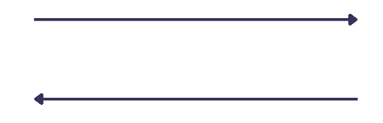
Process: The people, devices or procedures that transform the data. No physical components considered.

Source: It can be any of the people, programs, data, organization or data that are the external sources of the data.

Data Store: In a system the data are stored or processed in a data store.

Data Flow Diagram:
In Figure 3.3 there is DFD, which is very simple in nature. On left side we have user, which shows a hand sign in front of the camera live feed. Then frontend send that image to backend, where its preprocessed and then given to the TensorFlow model Which then predicts the character and give results in to the Current Alphabet Module.
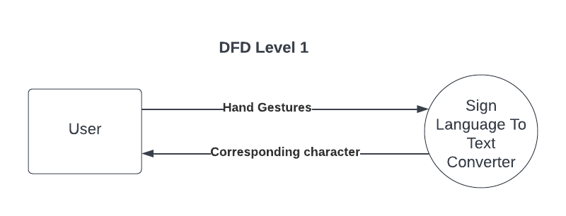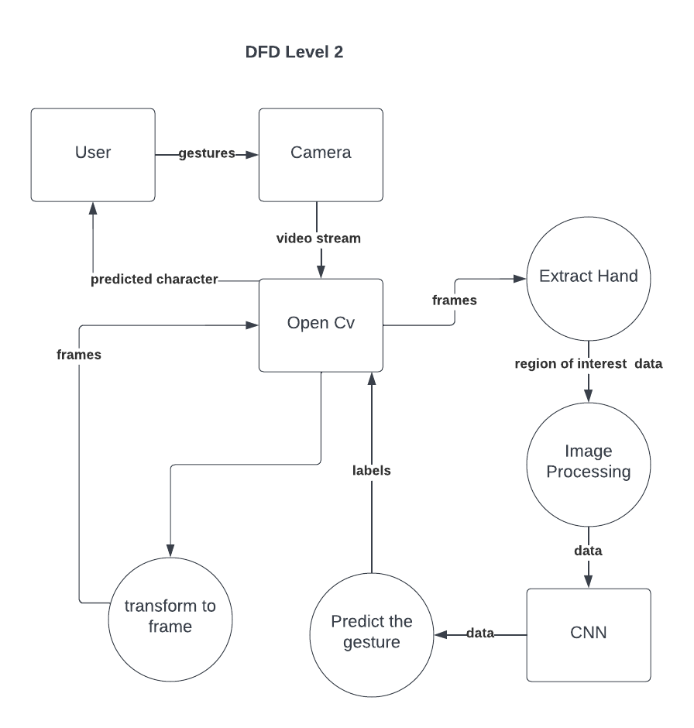
Figure 3.3: Data Flow Diagram

The data flow diagram (DFD) provides a closer look at how data moves within the system. It visualizes the sources, processes, and destinations of data as it is captured, processed, and outputted, offering insight into the internal operations of the application.
Sequence Diagram:
The sequence diagram is more detailed, showing the step-by-step flow of interactions between the system components and how data is processed over time. It explains the sequence in which processes are executed, from gesture detection to output.

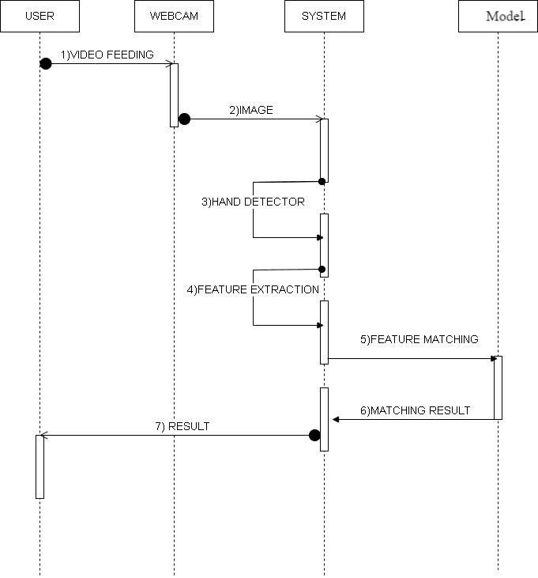
Figure 3.4: Sequence Diagram
The sequence diagram above demonstrates the flow of operations within the system. It provides a detailed breakdown of how various components interact to detect hand gestures and generate the appropriate output in real-time.

3.2.4 Dataset Collection
The captured data set for ASL recognition was done by taking pictures of hand signs for representing each of the alphabets in sign language with Mediapipe hand tracking. The hand-tracking library gave the opportunity to detect hand landmarks and follow hand movements in real time effectively and without significant delay. The captured hand gestures were then aligned to a white background image, this was so as to give an enhanced image processing and classification. The subsequent data set is potentially handy in building up ASL recognition ML models as well as aiding assistive technology. It is well known that Mediapipe hand tracking library is able to detect and track the human hands in real time due to deep learning. The library is built upon a lightweight convolutional neural network (CNN) model by training on millions of annotated hand images to discover the locations of the features and how they relating to each other. It also points out that the structure of the network is highly efficient and allows the application on different platforms such as Mobiles and computers.
The library begins by identifying the areas that belong to the hands on the input image by applying a bounding box regression. Then it passes on the detected hand regions to the hand landmark model to predict the location of each of the landmarks of the hands. Hand landmarks are 2D points and they are 21 of them in total; they denote the joints and fingertips of the hand.
When the hand landmarks are detected, the library can be employed in gesture recognition application, hand pose estimation, and augmented reality applications. The library also includes a collection of utility functions that allow for visualization of hand landmarks and the hand annotations and extraction of hand features as well as the removal of noise from landmarks.
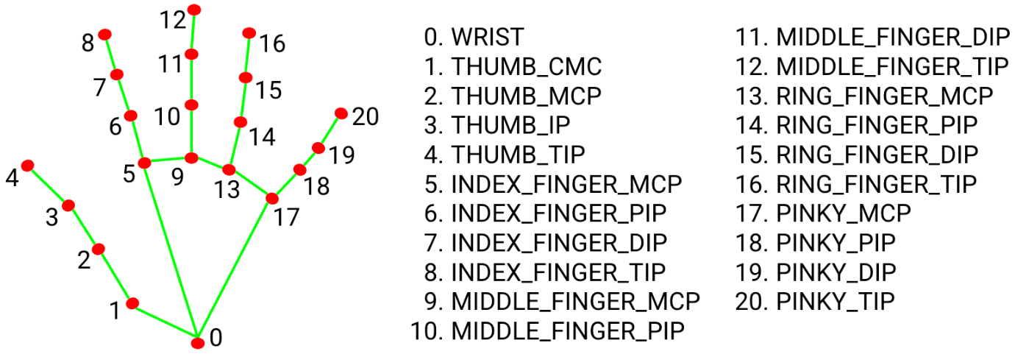
Figure 3.5: Mediapipe Hand Landmarks
3.2.5 Data Preprocessing
The preprocessing stage is a crucial step in preparing the dataset for training the deep learning model in the “HandTalk: Real-Time Hand Sign Recognition” system. The main objective was to sift out the noise from the hand sign images so that we obtain a set of hand images with only those features that are pertinent to recognition. For this project, the following preprocessing steps were carried out:
- Image Conversion to Mediapipe Skeleton: Each raw image containing the ASL hand signs was passed through Mediapipe's hand detection pipeline to extract the key hand landmarks. Mediapipe detected 21 specific points on the hand, including finger joints, tips, and the wrist. These points were then used to construct a skeleton-like representation of the hand. The skeleton consisted of lines connecting the key landmarks, providing a simplified but highly informative visual representation of the hand’s structure.
- Background Removal and White Background Application: After the skeleton was created, the background of the image was completely removed, leaving only the skeleton hand landmarks on a clean, white background. This transformation ensured that the deep learning model would focus exclusively on the hand gesture itself, without being influenced by any background distractions or lighting conditions.
- Image Resizing to 400x400 Dimensions: To maintain uniformity across the dataset, each skeleton image was resized to a fixed dimension of 400x400 pixels. This standardization ensured that all images fed into the deep learning model were of the same size, simplifying the learning process for the model and improving computational efficiency.
- Saving Pre-processed Images: The resulting 400x400 skeleton images with white backgrounds were saved and used as input for model training. This streamlined dataset, now consisting of clean, consistent hand gesture images, enabled the model to learn more effectively from the extracted hand structures, leading to improved accuracy during the recognition phase.
The first stage of preprocessing converted the raw hand sign images to simplified skeleton images, thus filtering out all the unnecessary information that would hinder the training of the model, while at the same time ensure that it achieves high accuracy and real-time response.

3.2.6 Preparation for Model Training
The next steps were training the deep learning model to distinguish hand signs as precisely as possible, before starting the training process proper, necessary preparations had to be made. This phase comprised arranging the formats of the pre-processed dataset, choosing suitable model architecture as well as setting up of training parameters environment.
The preprocessed data set had 4200 skeleton images with white background and was divided to training, validation and testing sets. This made it possible to train the model on part of the data, validate it on other samples to check up on the model’s performance, and finally test it on an entirely different data set so as to determine the model’s ability to generalize. In this phase, the choice of some of the parameters which include the batch size, learning rate and the number of epochs to be used for training the model were selected carefully. Further, to reduce overfitting and diversify the data additional preprocessing was performed which involved random rotation, flipping, and slight scaling of the images.
Lastly, the model was constructed with TensorFlow necessary for a skeleton hand landmark where each point would be an input to the network.
The training environment was also set to allow accelerate computation by the GPU to enhance the capability of training a deep learning model on the custom hand sign dataset. During this stage, a crucial step is to partition the dataset into three distinct subsets: Training, testing can be described as procedures used in the development of models to determine the accuracy of the results. The allocation percentages for these subsets will be 80% and 20% respectively. This division helps in making a certain degree that a vast portion of the overall data is used for model training, a comparatively small portion for testing while the remaining portion is used in validation split.
Moreover, in order to sharpen the model’s resilience and accuracy, there are also ways to conduct data augmentation to the images. In data augmentation, all manner of changes is made to the existing image and produce new instances of this image but with their representation of similar features. These augmentations help to reduce overfitting as they bring variation and diverseness in the training data set.
Data augmentation carries the advancement of being performed manually and through the use of other automated methods. Here some Augmentation Techniques are described as follows: Manual Augmentation includes turning, flipping, cropping, and splitting that is done in each image manually. While augmentation can be done manually where one is creative and adds improvements to the existing design, automation applies them mechanically using libraries and tools. That is in aided with tools like TensorFlow’s ImageDataGenerator or PyTorch’s torchvision transforms are provided by the augmentation library and all the augmentation options can be plugged into the data pipeline seamlessly. Thanks to data augmentation, we actually augment the training dataset and the model ‘learns’ from a wider range of situations. This also helps the model to learn and perform well on unseen data and prevent over-fitting the data it was trained on. Here Figure 3. 6 Image and making a conversion into a horizontal flip, different rotations, cropped image, changed contrast, and grayscale using Data Augmentation.
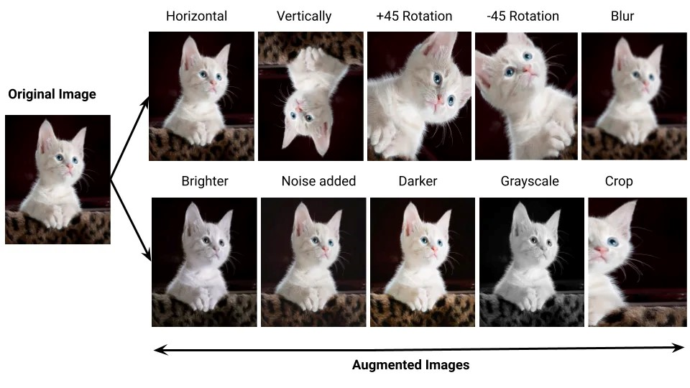
Figure 3.6: Augmentation Example

3.2.7 Convolutional Neural Networks and Layers
A Convolution Neural Network (ConvNet/CNN) is a Deep Learning algorithm that can take in an input image, assign importance (learnable weights and biases) to various aspects/objects in the image, and be able to differentiate one from the other. The pre-processing required in a ConvNet is much lower as compared to other classification algorithms. The architecture of a ConvNet is analogous to that of the connectivity pattern of Neurons in the Human Brain and was inspired by the organization of the Visual Cortex. Individual neurons respond to stimuli only in a restricted region of the visual field known as the Receptive Field.
A collection of such fields overlaps to cover the entire visual area. Convolutional neural networks or ConvNets are great at capturing local spatial patterns in the data. They are great at finding patterns and then using those to classify images. ConvNets explicitly assume that input to the network will be an image. CNNs, due to the presence of pooling layers, are insensitive to the rotation or translation of two similar images; i.e., an image and its rotated image will be classified as the same image. Due to the vast advantages of CNN in extracting the spatial features of an image, we have used the Inception-v3 model of the TensorFlow library which is a deep ConvNet to extract spatial features from the frames of video sequences. Inception is a huge image classification model with millions of parameters for images to classify.
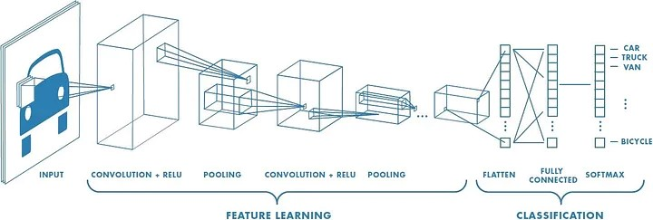
Figure 3.7: Convolutional Neural Network Architecture

Types of CNN Layers used in the Model building
In our project, we have implemented a three-layer Convolutional Neural Network (CNN) architecture, comprising the following components:
- Convolutional Layer:
In the convolution layer, I have taken a small window size [typically of length 5*5] that extends to the depth of the input matrix. The layer consists of learnable filters of window size. During every iteration, I slid the window by stride size [typically 1], and compute the dot product of filter entries and input values at a given position. As I continue this process will create a 2-Dimensional activation matrix that gives the response of that matrix at every spatial position. That is, the network will learn filters that activate when they see some type of visual feature such as an edge of some orientation or a blotch of some color.
- Pooling Layer:
We use a pooling layer to decrease the size of the activation matrix and ultimately reduce the learnable parameters. There are two types of pooling:
a. Max Pooling:
In max pooling, we take a window size [for example window of size 2*2], and only take the maximum of 4 values.
Well, lid this window and continue this process, so we’ll finally get an activation matrix half of its original Size.
b. Average Pooling:
In average pooling, we take an average of all Values in a window.
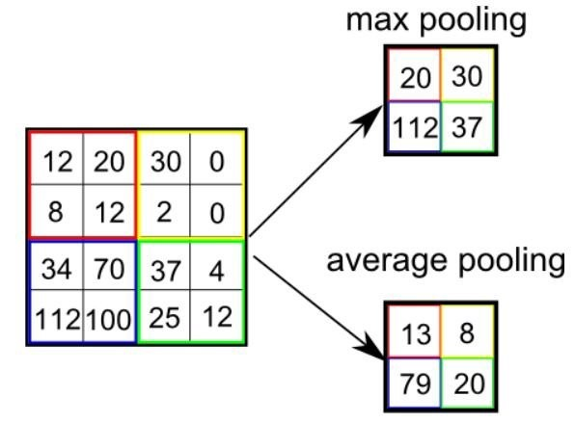
Figure 3.8: Pooling Layer

- Fully Connected Layer:
In the convolution layer neurons are connected only to a local region, while in a fully connected region, well connect all the inputs to neurons.
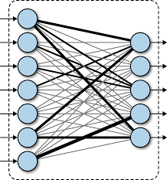
Figure 3.9: Fully Connected Layers
- Final Output Layer:
In the convolution layer neurons are connected only to a local region, while in a fully connected region, well connect all the inputs to neurons. After getting values from the fully connected layer, well connect them to the final layer of neurons [having a count equal to a total number of classes], which will predict the probability of each image being in different classes.
- Rectified Linear Activation (ReLU):
Introducing non-linearity, the ReLU function significantly expedites the training process, rendering computations faster and more efficient. This choice of activation function plays a pivotal role in enabling the network to capture complex relationships and nuances present within the data.
In Figure 3.10 all the layers are visible and help to identify the Koala Bear with the process of feature extraction and classification.
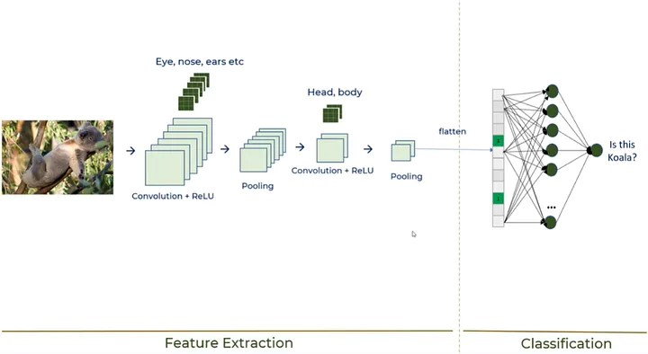
Figure 3.10: CNN With All Layers

3.2.8 Hardware & Software Used
Hardware Used
For applications or websites to run efficiently on a system, it is necessary to provide the required software and hardware components. If not done so, the system may behave unexpectedly or may even crash.
Application are as follows:
Operating System | Processor | RAM
All Windows (32/64 bit), | Pentium III® or | 2 GB
Mac OS | equivalent processor | 2 GB

Software Used
Technology | TENSORFLOW, KERAS, MATPLOTLIB, NUMPY, PANDAS, MEDIAPIPE, CUSTOM TKINTER
Platform | Windows 10
IDE | Anaconda Navigator, Jupyter Notebook, VS Code

3.3 Technology and Overview
The “HandTalk: Real-Time Hand Sign Recognition” project integrates a combination of frontend, backend, and deep learning technologies to provide an efficient, user-friendly, and high-performance system. Each technology plays a vital role in delivering the application's functionality, from capturing live video input to recognizing hand signs and displaying results.

3.3.1 Frontend Technology
The frontend of HandTalk is developed using Tkinter, a popular GUI library in Python, which provides a simple yet powerful interface for desktop applications. Tkinter was chosen due to its ease of use and flexibility in designing custom graphical user interfaces. The following features are implemented through Tkinter:
- Live Camera Feed Display: The live camera feed, which captures the user's hand gestures, is embedded within the Tkinter window.
- Real-Time Gesture Display: The recognized alphabets, words, and word suggestions are displayed interactively on the screen.
- User Controls: Custom buttons like "Clear" and "Speak" are implemented for user interaction, allowing users to reset the input or hear the recognized word through text-to-speech.
Tkinter’s simplicity, along with its compatibility with Python-based projects, makes it an ideal choice for developing the custom GUI for HandTalk.

3.3.2 Backend Technology
The backend of the application is powered by Python itself a lightweight GUI framework. Tkinter manages the interaction between the frontend and the deep learning model, handling the real-time data flow. The backend functionalities include:
- Model Inference: OpenCV receives the processed hand landmark data from Mediapipe and forwards it to the TensorFlow model for sign recognition.
- Response Management: The backend processes the output from the model, formatting it for display in the frontend (recognized alphabet, word construction, and word suggestions).
- Text-to-Speech Integration: Tkinter also handles the conversion of the recognized word into speech when the "Speak" button is triggered, providing the audio feedback to the user.
Tkinter’s simplicity and flexibility made it the optimal choice for handling real-time backend processes while keeping the architecture lightweight and responsive.

3.3.3 DL Technology
The core functionality of HandTalk relies on cutting-edge deep learning technologies and hand-tracking frameworks, ensuring accurate and efficient sign language recognition.
- Mediapipe: Mediapipe is used for real-time hand tracking and landmark extraction. It detects 21 key landmarks on the hand and feeds this skeletal information to the deep learning model. Mediapipe's speed and accuracy make it ideal for real-time gesture recognition in the application.
- TensorFlow: TensorFlow is a free and open-source software library for machine learning and artificial intelligence. It can be used across a range of tasks but has a particular focus on training and inference of deep neural networks. TensorFlow was developed by the Google Brain team for internal Google use in research and production. The initial version was released under the Apache License 2.0 in 2015. Google released the updated version of TensorFlow, named TensorFlow 2.0, in September 2019. TensorFlow can be used in a wide variety of programming languages, including Python, JavaScript, C++, and Java. This flexibility lends itself to a range of applications in many different sectors.
- Keras: Keras is an open-source library that provides a Python interface for artificial neural networks. Keras acts as an interface for the TensorFlow library. Up until version 2.3, Keras supported multiple backends, including TensorFlow, Microsoft Cognitive Toolkit, Theano, and PlaidML. As of version 2.4, only TensorFlow is supported. However, starting with version 3.0 (including its preview version, Keras Core), Keras will become multi-backend again, supporting TensorFlow, JAX, and PyTorch. Designed to enable fast experimentation with deep neural networks, it focuses on being user-friendly, modular, and extensible.
These deep learning and machine learning technologies work together to ensure real-time, accurate recognition of ASL gestures, providing a seamless experience for the end user.

3.4 Requirement and Analysis
The requirement analysis for “HandTalk: Real-Time Hand Sign Recognition” project involves identifying both functional and non-functional requirements that define system's capabilities and performance criteria. This analysis ensures that application meets user needs and operates efficiently under various conditions.

3.4.1 Functional Requirements
Functional requirements describe the specific behaviors and functions that the system must support to fulfill its purpose. For the HandTalk application, the following functional requirements have been identified:
- Live Camera Feed:
  - The system must capture and display live video from the user’s webcam and send it for further feature extraction.
  - The video feed should be processed in real time to ensure immediate recognition of hand signs.
- Hand Sign Recognition:
  - The system must accurately detect and recognize ASL hand signs using Mediapipe for hand tracking and TensorFlow for deep learning-based classification.
  - It should support recognition of the full ASL alphabet (A-Z) as well as additional commands for "Next" and "Backspace."
- Feature Display:
  - The application must display the recognized hand sign alphabet and word on the screen.
  - It should provide a visual representation of the ASL hand signs for user reference.
- Word Construction and Suggestions:
  - The system must dynamically construct and display words from recognized alphabets.
  - It should provide word suggestions based on the currently recognized sequence of alphabets.
- User Interaction Controls:
  - Clear Button: Users should be able to clear the current input and reset the recognition process with a single button press.
  - Speak Button: The system must convert the recognized word into speech and play it aloud when the "Speak" button is pressed.
- Real-Time Performance:
  - The application must ensure that all processes, including hand sign recognition and feedback display, occur in real time with minimal delay.

3.4.2 Non-Functional Requirements
Non-functional requirements define the system's operational attributes and performance standards. For HandTalk application, the following non-functional requirements are crucial:
- Performance:
  - The system must provide real-time processing with minimal latency in recognizing and displaying hand signs.
  - The response time for user interactions (e.g., pressing buttons) should be swift to enhance user experience.
- Usability:
  - The user interface should be intuitive and easy to navigate, with clear visual cues and controls.
  - The system must be accessible to users with varying levels of familiarity with technology and sign language.
- Reliability:
  - The application must perform consistently under different conditions, such as varying lighting and hand positions.
  - It should handle edge cases gracefully, such as when the hand is partially out of the camera frame or obscured.
- Scalability:
  - The system should be designed to accommodate future enhancements, such as the addition of new hand signs or language support.
  - It must be able to handle different screen resolutions and adapt to various display sizes.
- Security:
  - The application must ensure that no personal data or video feed is stored or misused.
  - Any user interaction data should be processed securely, following best practices for data privacy.
- Compatibility:
  - The application should be compatible with commonly used operating systems, such as Windows and macOS.
  - It must support integration with various hardware configurations, including different webcam models.
By addressing both functional and non-functional requirements, The HandTalk application is designed to deliver an effective and user-friendly solution for real-time ASL recognition, ensuring both high performance and a positive user experience.

